Web Development Lesson Plan

|  |  |  |
| --- | --- | --- |
| Session: 2 | Topic: Creating your first Django project | Day: 2 |

|  |
| --- |
| Lesson Objective:  This exercise will...   * Instruct students how create their own Django project folder   The purpose of this lesson is also that   * Students will practice Django commands. |
| Materials Needed:   * VS Code * Internet connection |
| Agenda:   1. Setup project folder (5 minutes) 2. Create virtual environment (5 minutes) 3. Create Django project (10 minutes) |
| Procedure:  Student can do this fully independently by reading the instructions, or someone can read the instructions to make sure the task is understood before doing the activity. The reflection part can be done with guided instructions, or in pairs with other students if available to compare notes. |
| Assessment/Check for learning:   * Students can identify concrete things that they missed in their observation (note that this is not a bad thing, the purpose of this lesson is to realize that intentionally looking for information comes with the ‘penalty’ of reduced attention to other things. |

What if:

* Student has already shown proficiency in that skill?
  + Pick a movie or episode in which a lot of things are happening, so that there are more things for the student to keep track of.
* Student is having a hard day and needs special accommodations?
  + Pick a movie or episode in which only a few things are happening, so that there are less things for the student to keep track of.
  + Instead of writing, the student can also take spoken notes with an audio recorder. This will be a bit trickier in the second part but audio in the movie can be supported with subtitles.

NOTES:

* Duration is approximately 50 minutes; can be adjusted by shortening the duration of the film clip. Less than 10 minutes is not recommended unless really necessary.

**Instructions**

**Setup project folder (5 minutes)**

Step 1:

In a VS Code terminal run the **mkdir** command to create a folder called “Lesson10”

mkdir Lesson10

Step 2:

Now in the VS Code side bar, open the folder you created. If you do not see the side bard use the following keyboard shortcut: CMD + B (Mac) Windows Key + B (Windows). You can also click on the first icon in the left menu bar.

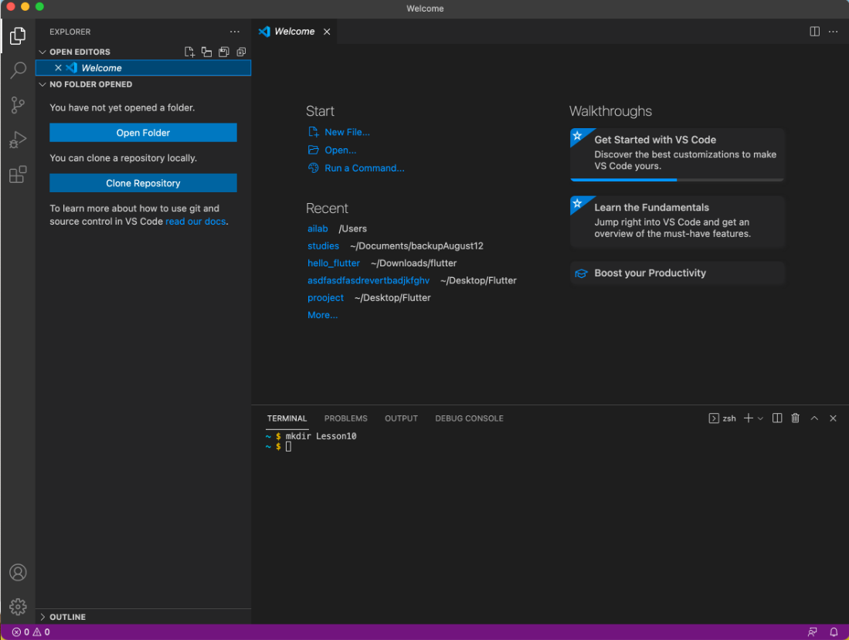

Step 3:

Click on “Open Folder”. Open Lesson10. The page will refresh and your terminal might disappear, if it does simply open a new terminal. You will now see the Lesson10 file structure in the left side bar. It will be empty as of this step.  
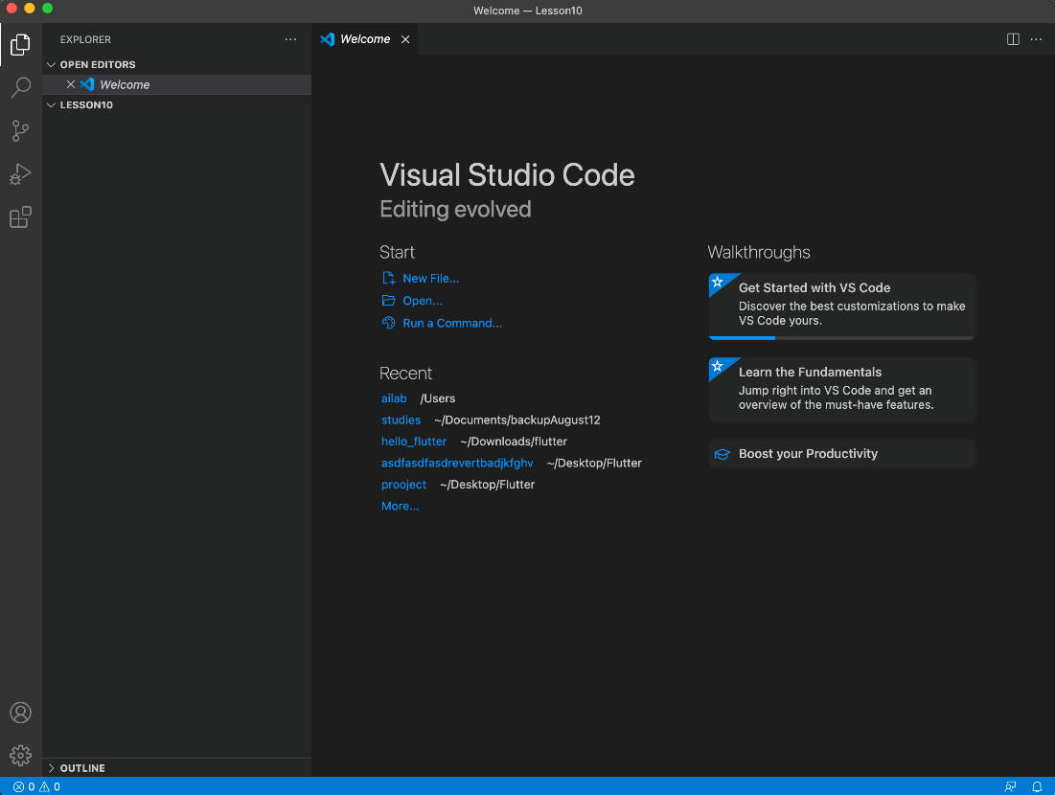

Do not close the window, we will continue to work in this window for the next steps.

**Create virtual environment (5 minutes)**

Step 1:

Within the same VS Code window open a terminal if you have not done so already.

Step 2:

Create a virtual environment with the following command. After running the command you will see the “env” folder in the side bar.

virtualenv env –p python3

Step 3:

Activate the virtual environment with:

source env/bin/activate

**Create Django project (10 minutes)**

Step 1:

Before we start, we will install Django. We need to install Django again because we are using a different virtual environment. To install Django run the following:

pip install Django==3.2.6

Step 2:

Now that we have installed Django, we will run the following command to create a Django project. This command will create a new fodler with all the files that we need to start building a web app. Run the following command:

django-admin startproject blog

Note: In the command above “blog” is the name of our project. In the future you can change this name to anything you like.

Step 3:

You will now see a folder called blog:

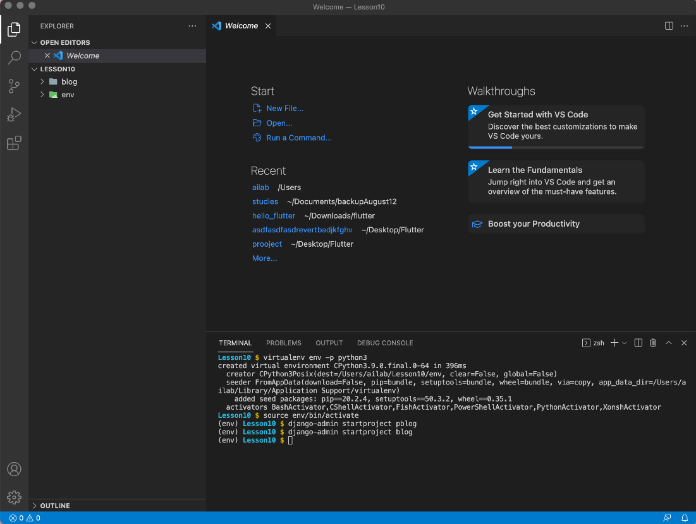

Step 4:

Click on the drop arrow next to the folder to view the contents of the folder. You will see the following:

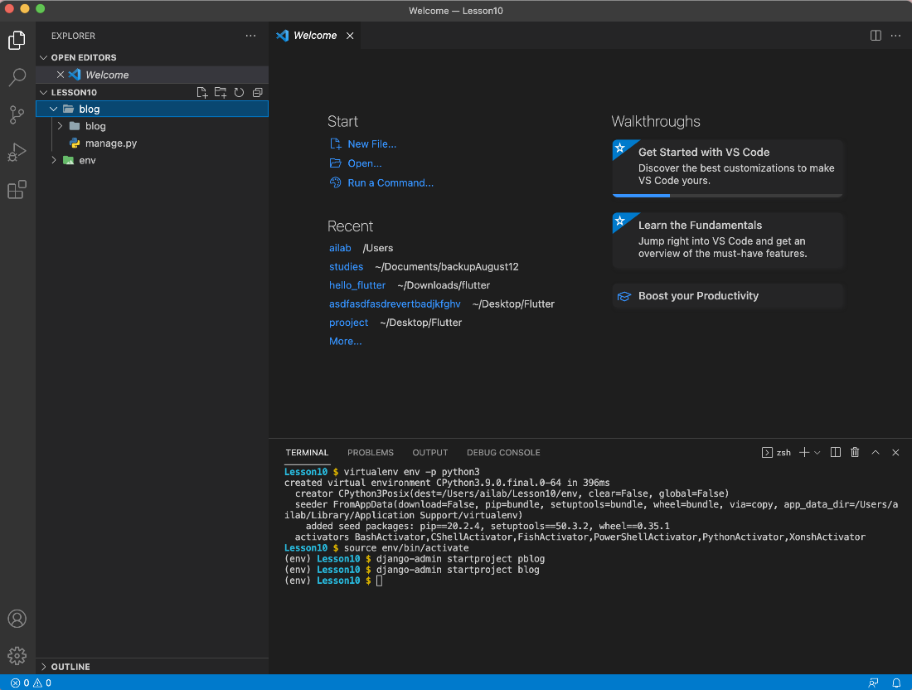

Step 5:

You will see another folder called “blog”. Expand this folder by clicking on the arrow. This folder contains project files. Everything we do will be inside this second “blog” folder.

Step 6:

You have now successfully created a Django project folder. In the next lesson we will create a Django app.

In the following lesson you will create your first Django app.